|  |
| --- |
| **Software Engineering and Practice**  **Assignment #2** |



|  |  |
| --- | --- |
| **Group** | 10 |
| **Members** | JEON JEHUN, BOHM NATALIE BEATRICE |

1. **Use case Diagram**

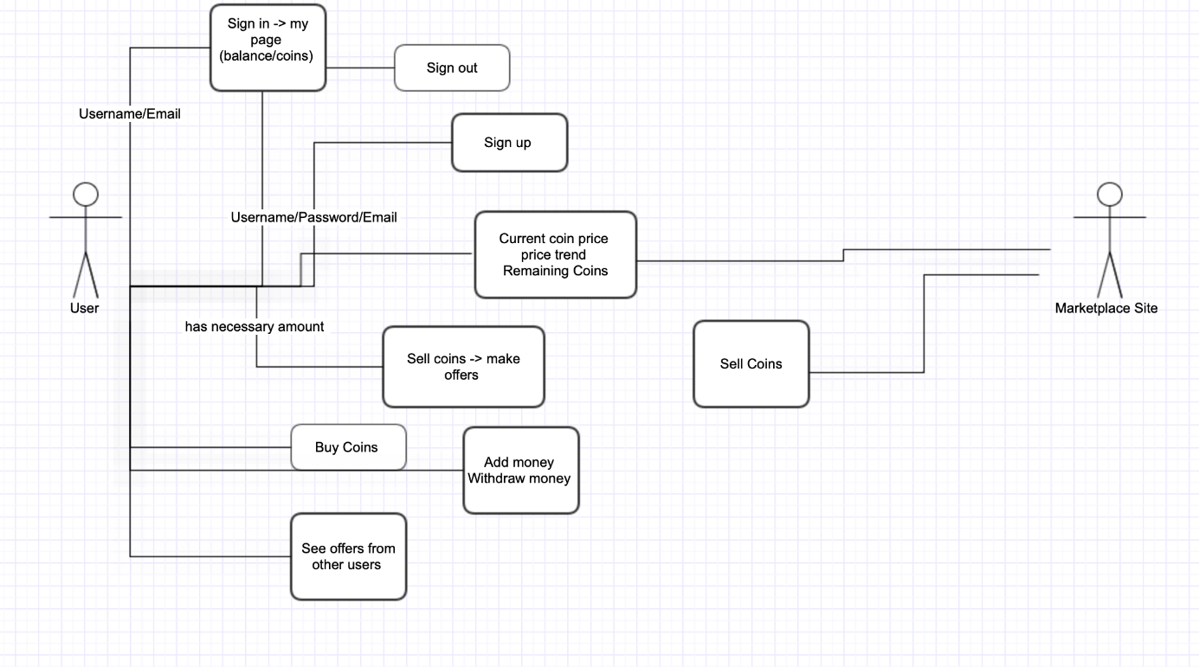

1. **Use Cases**
2. Sign Up

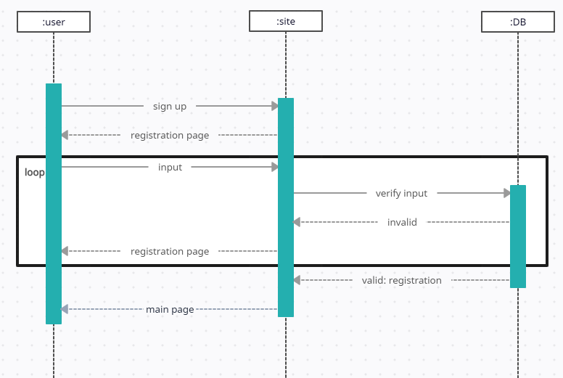

1. See the current coin price

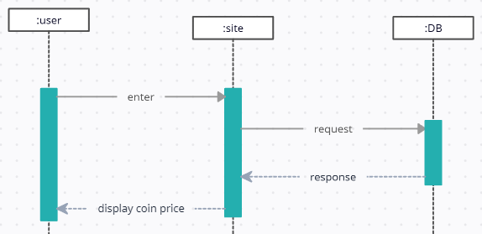

1. Update remaining coins

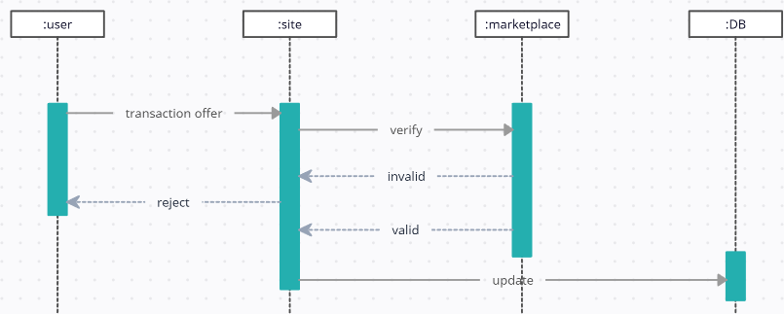

1. Post selling coins

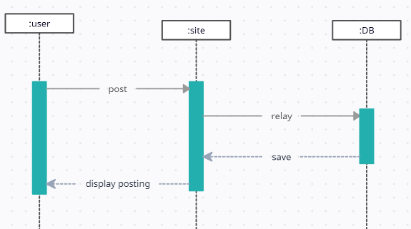

1. Update seller’s and buyer’s infromation up to date

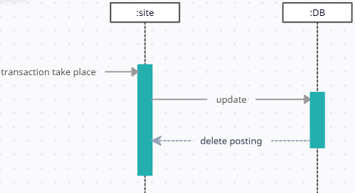

1. Sign in

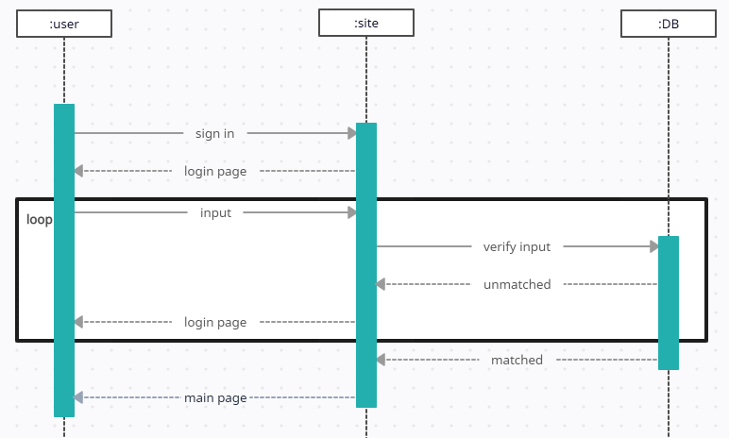

1. Buy coins from marketplace

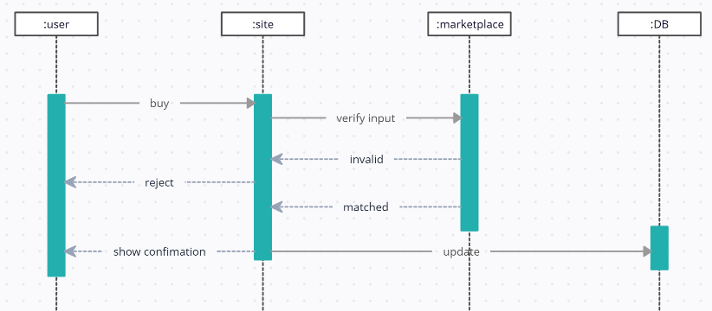

1. Show price trends

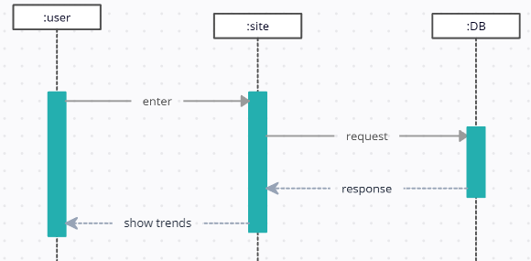

1. Sign out

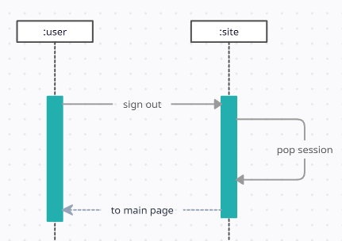

**3. Class diagram**

Ein Bild, das Text, Diagramm, Screenshot, parallel enthält.
